Provincial Dental Board of Nova Scotia

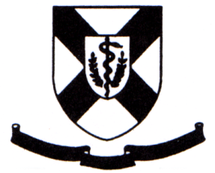

Personal & Confidential

Dr. Martin R. Gillis, Registrar
Provincial Dental Board of Nova Scotia
Suite103
210 Waterfront Drive
Bedford, NS B4A 0H3
Fax: 902-492-0301

CONSENT TO RELEASE OF INFORMATION

I, ____________________________, hereby give consent for the Provincial Dental Board of Nova Scotia to provide the __________________________________any information requested, by the Office of the Registrar concerning my licensure with the province of Nova Scotia including any formal disciplinary action by the Provincial Dental Board.

Signature Witness (sign)

______________________________

Date Witness (print name)

Please provide complete mailing address for the Letter of Good Standing.

